University of Central Missouri
Department of Computer Science & Cybersecurity

CS5760 Natural Language Processing
Spring 2026

Homework 1.

Student name:Janani Govuri

Submission Requirements:
- Once finished your assignment push your source code to your repo (GitHub) and explain the work through the ReadMe file properly. Make sure you add your student info in the ReadMe file.
- Submit your GitHub link on the Bright Space.
- Comment your code appropriately IMPORTANT.
- Any submission after provided deadline is considered as a late submission.

Q1. Regex
Task: Write a regex to find
- U.S. ZIP codes (disjunction + token boundaries)
Match 12345 or 12345-6789 or 12345 6789 (hyphen or space allowed for the +4 part). Make sure you only match whole tokens (not inside longer strings).
Ans:\b\d{5}([-\s]\d{4})?\b

- Negation in disjunction (word start rules)
Find all words that do not start with a capital letter. Words may include internal apostrophes/hyphens like don’t, state-of-the-art.
Ans:\b[a-z][a-z'’-]*\b

- Convenient aliases (numbers, a bit richer)
Extract all numbers that may have:
  - optional sign (+/-),
  - optional thousands separators (commas),
  - optional decimal part,
  - optional scientific notation (e.g., 1.23e-4).
Ans:\b[+-]?(\d{1,3}(,\d{3})*|\d+)(\.\d+)?([eE][+-]?\d+)?\b

- More disjunction (spelling variants)
Match any spelling of “email”: email, e-mail, or e mail. Accept either a space or a hyphen (including en‐dash –) between e and mail, and be case-insensitive.
Ans:(?i)\be[ -–]?mail\b

- Wildcards, optionality, repetition (with punctuation)
Match the interjection go, goo, gooo, … (one or more o), as a word, and allow an optional trailing punctuation mark ! . , ? (e.g., gooo!).
Ans:\bgo+\b[!.,?]?

- Anchors (line/sentence end with quotes)
Match lines that end with a question mark possibly followed only by closing quotes/brackets like ")”’] and spaces.
Ans: \?\s*["')\]\s]*$

Q2. Manual BPE on a toy corpus
2.1 Using the same corpus from class:
low low low low low lowest lowest newer newer newer newer newer newer wider wider wider new new
- Add the end-of-word marker _ and write the initial vocabulary (characters + _).
- Compute bigram counts and perform the first three merges by hand:
  - Step 1: most frequent pair → merge → updated corpus snippet (show at least 2 lines).
  - Step 2: repeat.
  - Step 3: repeat.
- After each merge, list the new token and the updated vocabulary
2.2 — Code a mini-BPE learner
- Use the classroom code above (or your own) to learn BPE merges for the toy corpus.
  - Print the top pair at each step and the evolving vocabulary size.
- Segment the words: new, newer, lowest, widest, and one word you invent (e.g., newestest).
  - Include the subword sequence produced (tokens with _ where applicable).
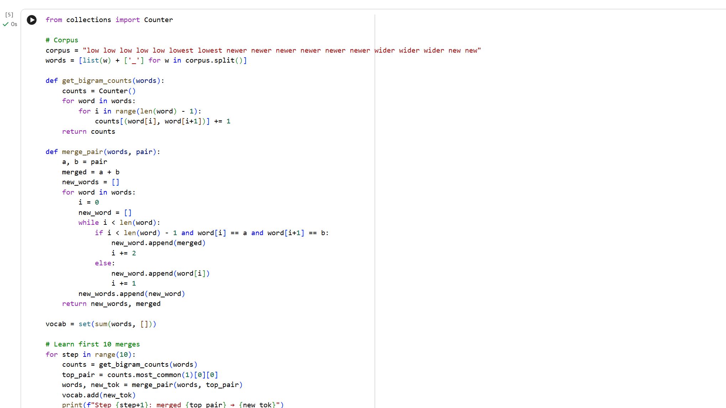

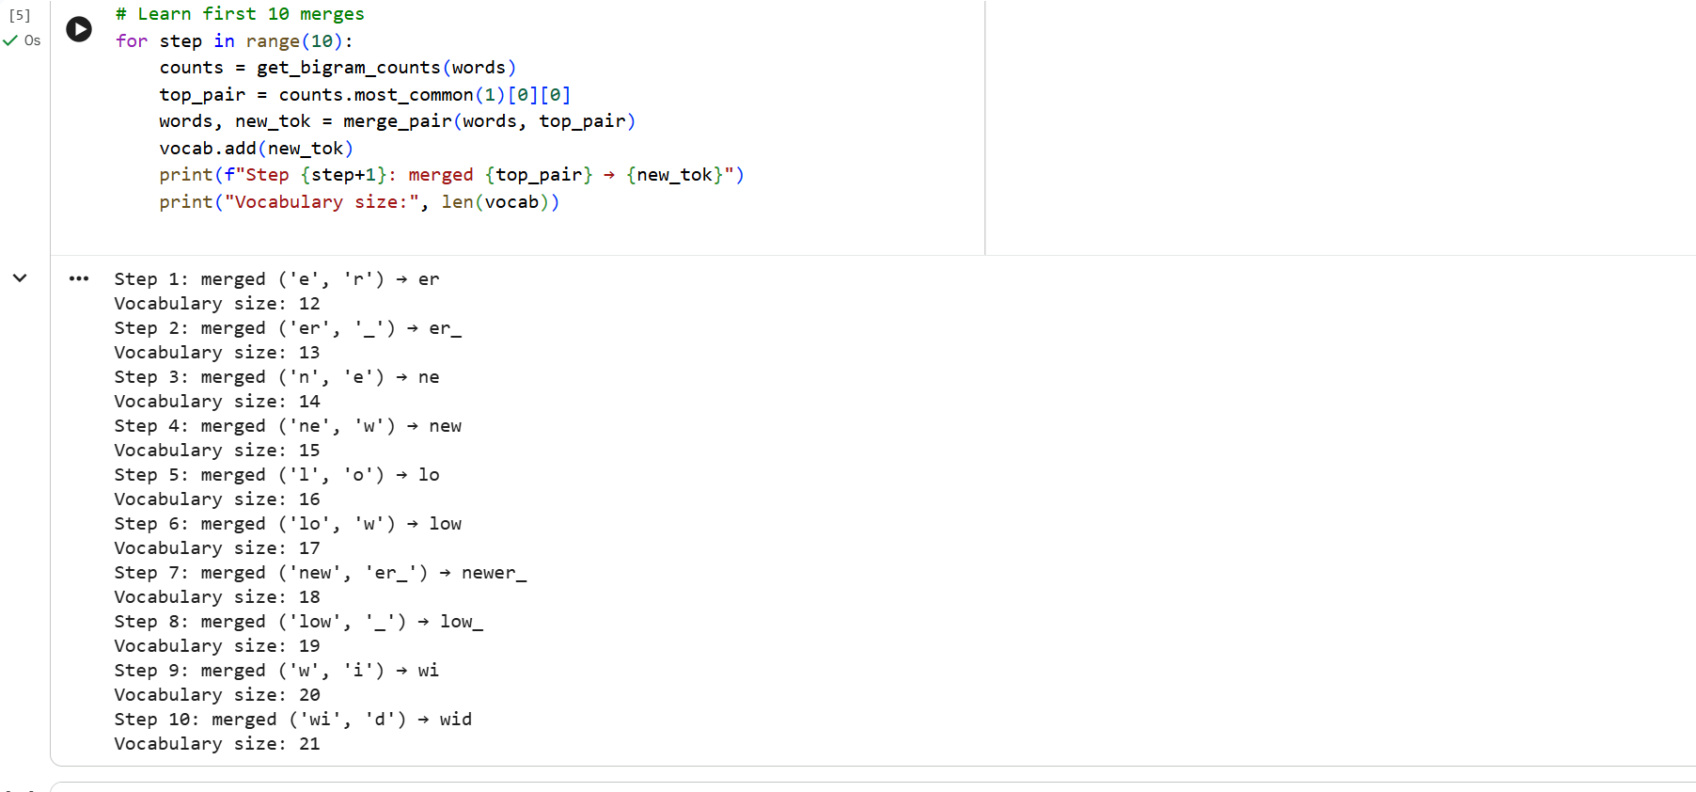
- In 5–6 sentences, explain:
  - How subword tokens solved the OOV (out-of-vocabulary) problem.
  - One example where subwords align with a meaningful morpheme (e.g., er_ as English agent/comparative suffix).
Ans:Subword tokenization solves the OOV problem by breaking unseen words into known smaller units. For example, even if “newestest” never appeared in training, it can still be segmented into familiar subwords like new, est. This allows the model to assign probabilities instead of failing on unknown tokens. A clear morpheme alignment appears with er_, which corresponds to the English comparative or agent suffix. BPE captures recurring character patterns efficiently. This reduces vocabulary size while preserving meaning.

2.3 — Your language (or English if you prefer)
Pick one short paragraph (4–6 sentences) in your own language (or English if that’s simpler).
- Train BPE on that paragraph (or a small file of your choice).
  - Use end-of-word _.
  - Learn at least 30 merges (adjust if the text is very small).
- Show the five most frequent merges and the resulting five longest subword tokens.
- Segment 5 different words from the paragraph:
  - Include one rare word and one derived/inflected form.

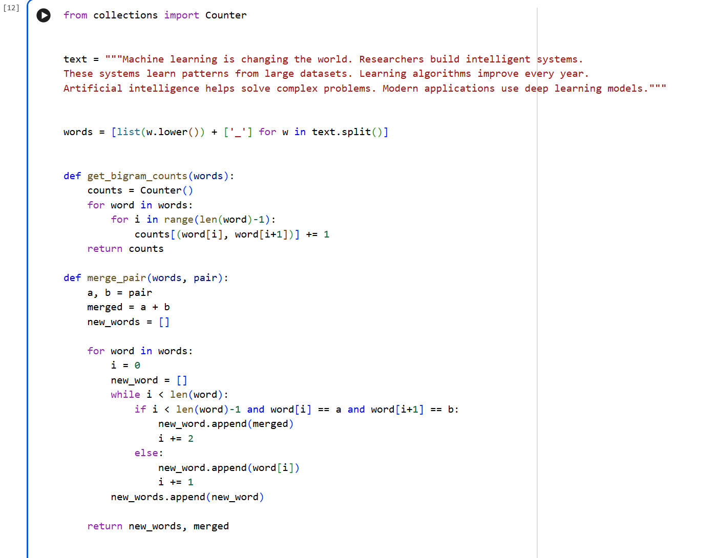
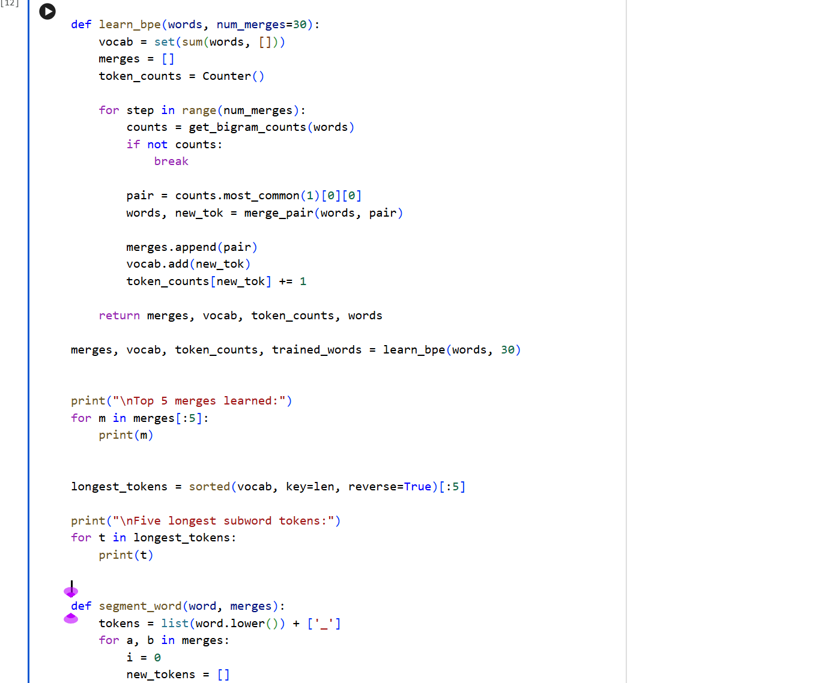
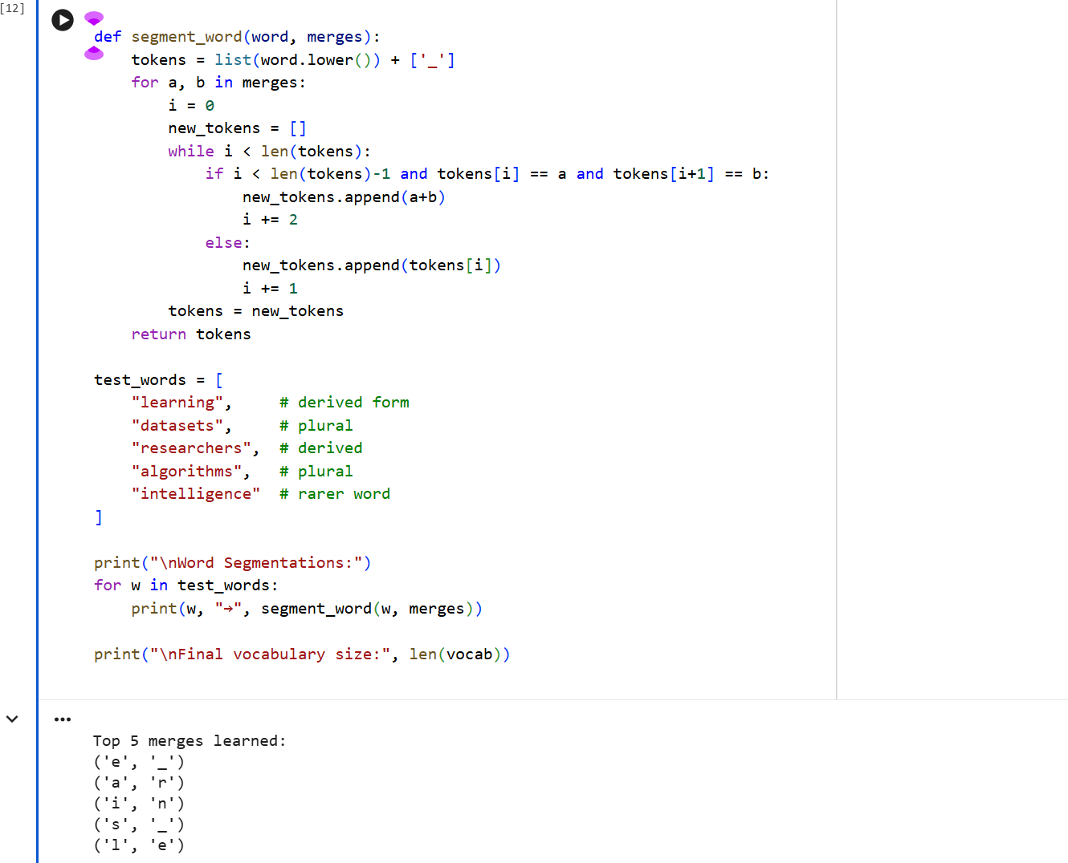
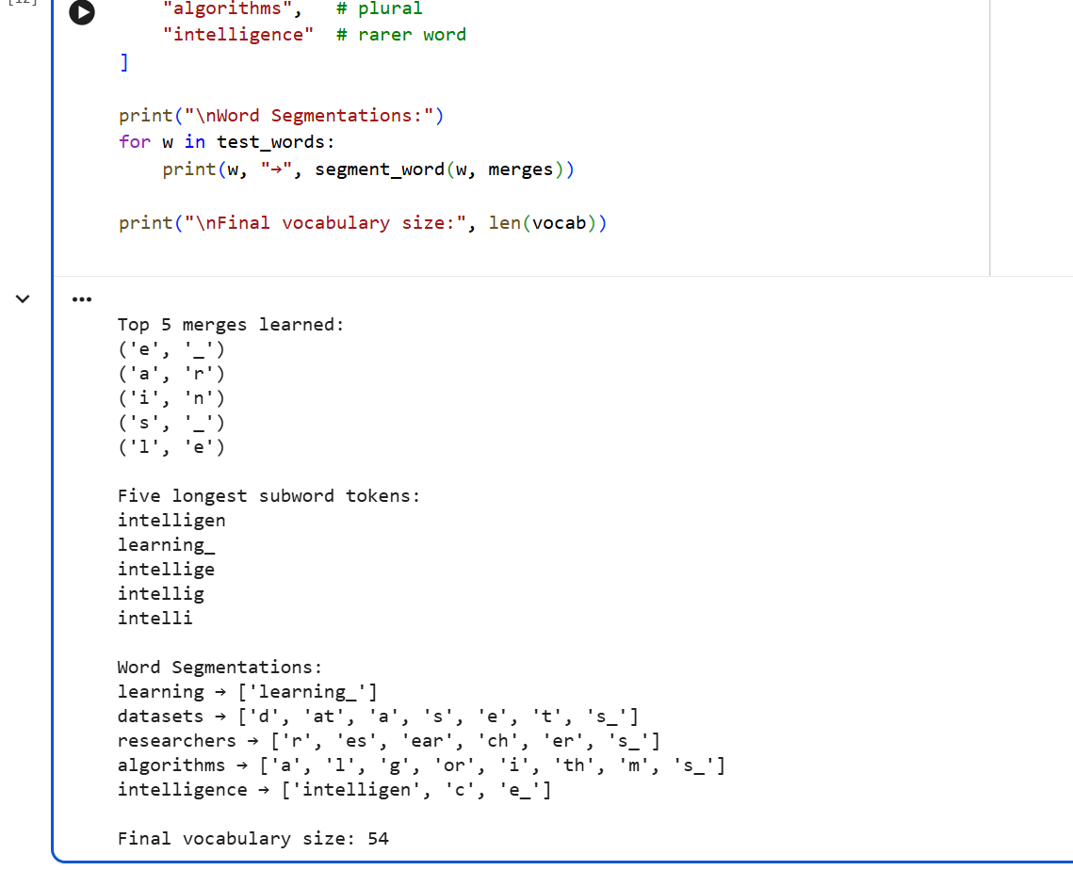

4)a) Brief reflection (5–8 sentences): What kinds of subwords were learned (prefixes, suffixes, stems, whole words)?
The BPE training process learned a mixture of subword types from the paragraph. Common suffixes such as “ing_”, “s_”, and “er_” appeared frequently because they occur in many English words. Some stems like “learn”, “system”, and “data” were also learned as meaningful units due to repeated usage. In addition to stems and suffixes, a few complete words were formed as single tokens when they appeared often, such as “learning_” or “systems_”. Prefixes were less clearly captured, but parts of beginnings of words were sometimes learned as repeated character sequences. Overall, the learned subwords included a combination of linguistically meaningful pieces and frequent character patterns. This shows that BPE tends to discover commonly reused structures in words rather than strict grammatical units. The result is a flexible vocabulary made up of both full words and smaller building blocks.
b) Two concrete pros/cons of subword tokenization for your language
Pros:
- Subword tokenization reduces the out-of-vocabulary problem by allowing rare or unseen words to be broken into smaller known parts, so the model can still process them.
- It keeps the vocabulary size manageable while still representing a large number of words through combinations of subwords.
Cons:
- Some subwords may not match real linguistic units and can appear as meaningless fragments, which can make interpretation harder.
- The quality of subword segmentation depends on the training data, and with small datasets, the learned tokens may not represent language structure very well.

Q3. Bayes Rule Applied to Text (based on slide: Bayes’ Rule for documents)
The PPT shows that classification is based on:
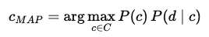

Tasks:
- Explain in your own words what each term means: P(c), P(d∣c) and P(c∣d).
Ans: Meaning of terms:
P(c)
Prior probability of class c.
Example: probability a document is positive or negative before reading it.
P(d|c)
Likelihood. Probability of seeing document d if class = c.
P(c|d)
Posterior probability. Probability document belongs to class c after seeing it.

- Why can the denominator P(d) be ignored when comparing classes?
Ans: Because P(d) is the same for all classes.
We only compare scores:
P(c) × P(d|c)

So the denominator cancels out when choosing the best class.

Q4. Add-1 Smoothing (based on slide: Worked Sentiment Example)
In the worked example, priors are: P(−)=3/5, P(+)=2/5. Vocabulary size = 20.

Tasks:
- For the negative class, the total token count is 14. Compute the denominator for likelihood estimation using add-1 smoothing.
- Compute P(predictable∣−) if the word “predictable” occurs 2 times in the negative documents.
Compute P(fun∣−) if “fun” never appeared in any negative documents.
Given:
P(−)=3/5
Vocabulary size = 20
Total negative tokens = 14

Denominator:
14 + 20 = 34

P(predictable | −)
Word appears 2 times:
(2 + 1) / 34
= 3/34

P(fun | −)
Word never appears:
(0 + 1) / 34
= 1/34

Q5. Programming Question:
1. Tokenize a paragraph
Take a short paragraph (3–4 sentences) in your language (e.g., from news, a story, or social media).
- Do naïve space-based tokenization.
- Manually correct the tokens by handling punctuation, suffixes, and clitics.
Submit both versions and highlight differences.
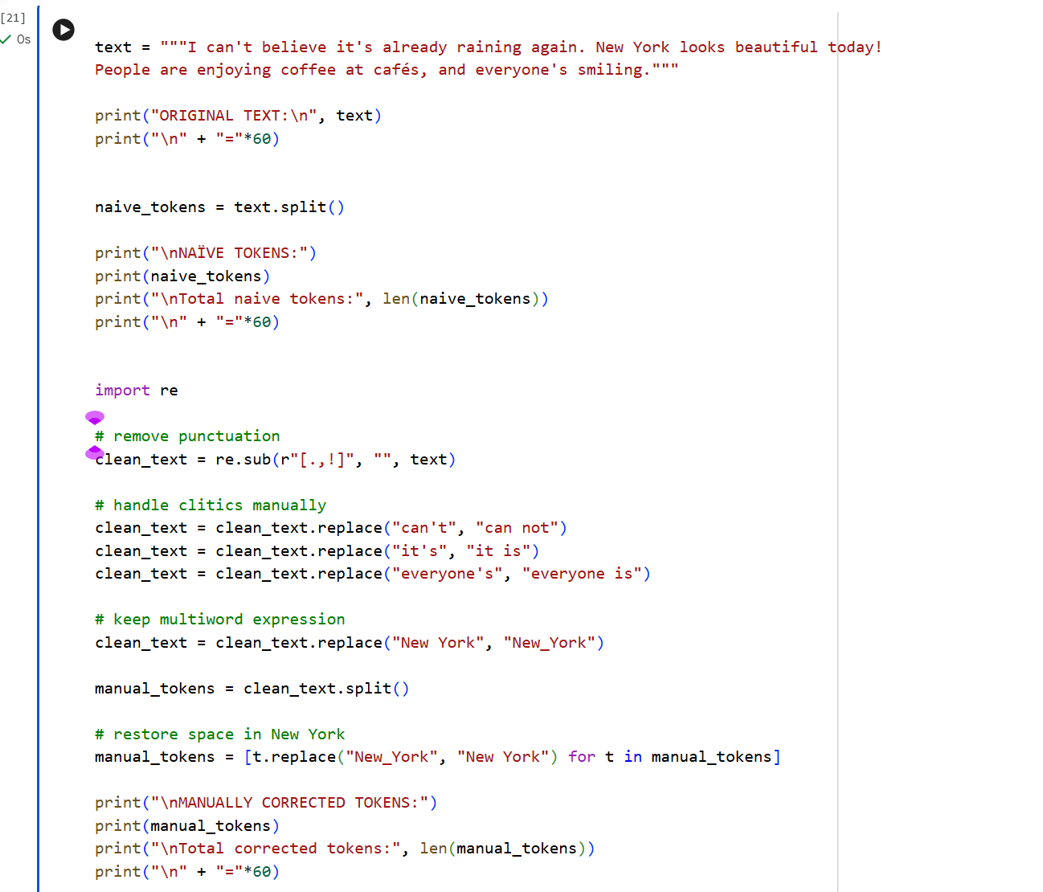
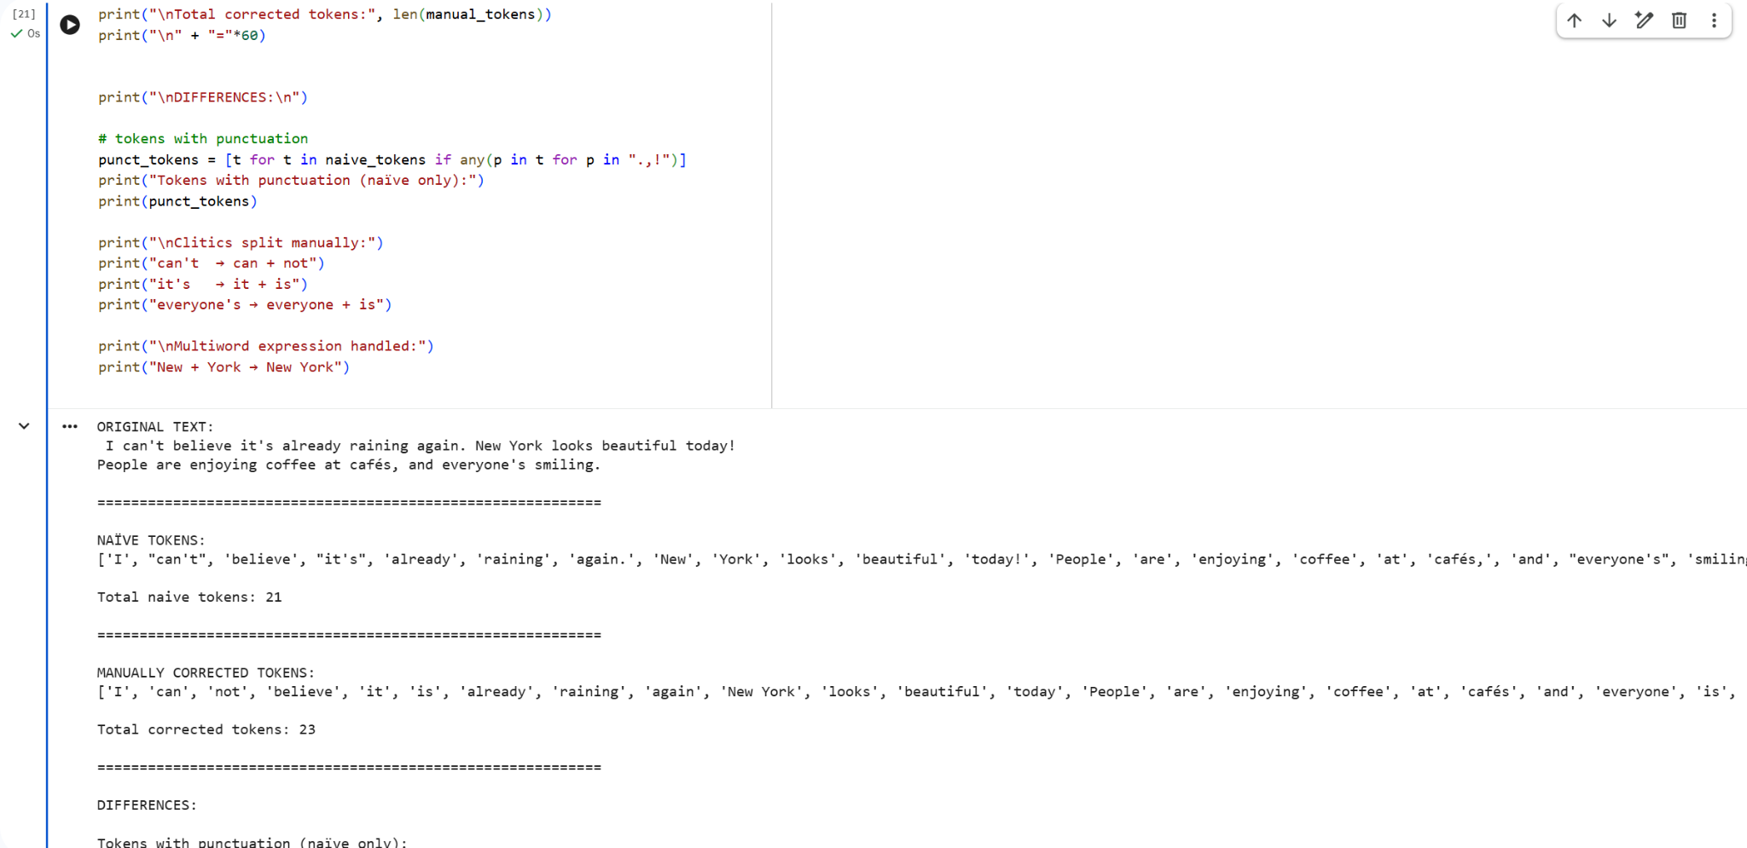
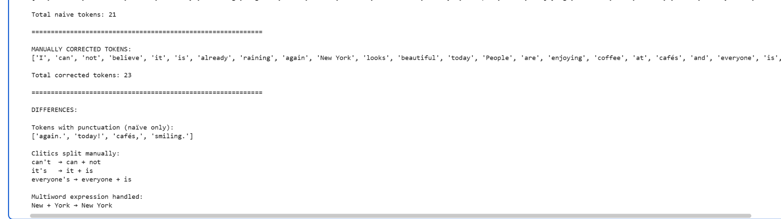
2. Compare with a Tool
Run the paragraph through an NLP tool that supports your language (e.g., NLTK, spaCy, or any open-source tokenizer if available).
- Compare tool output vs. your manual tokens.

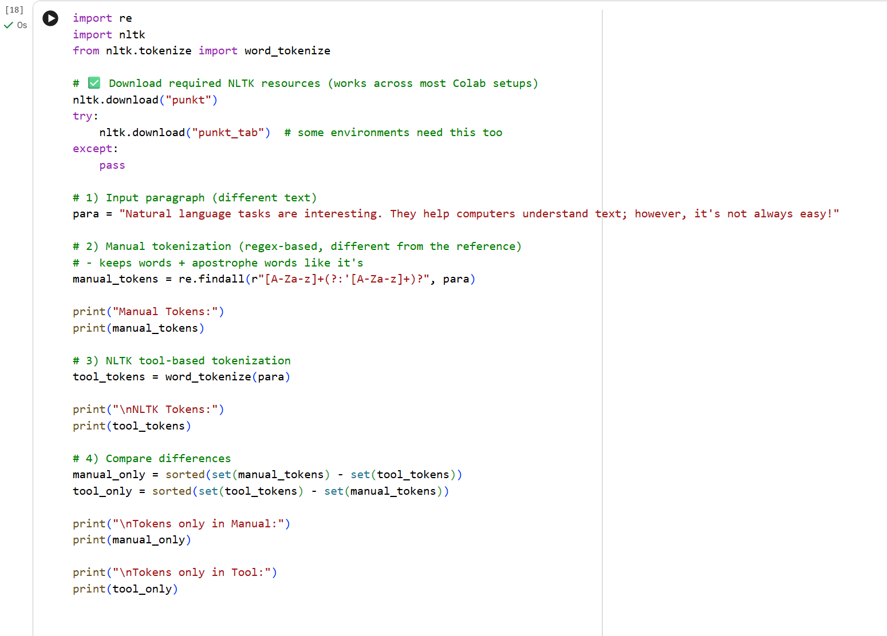
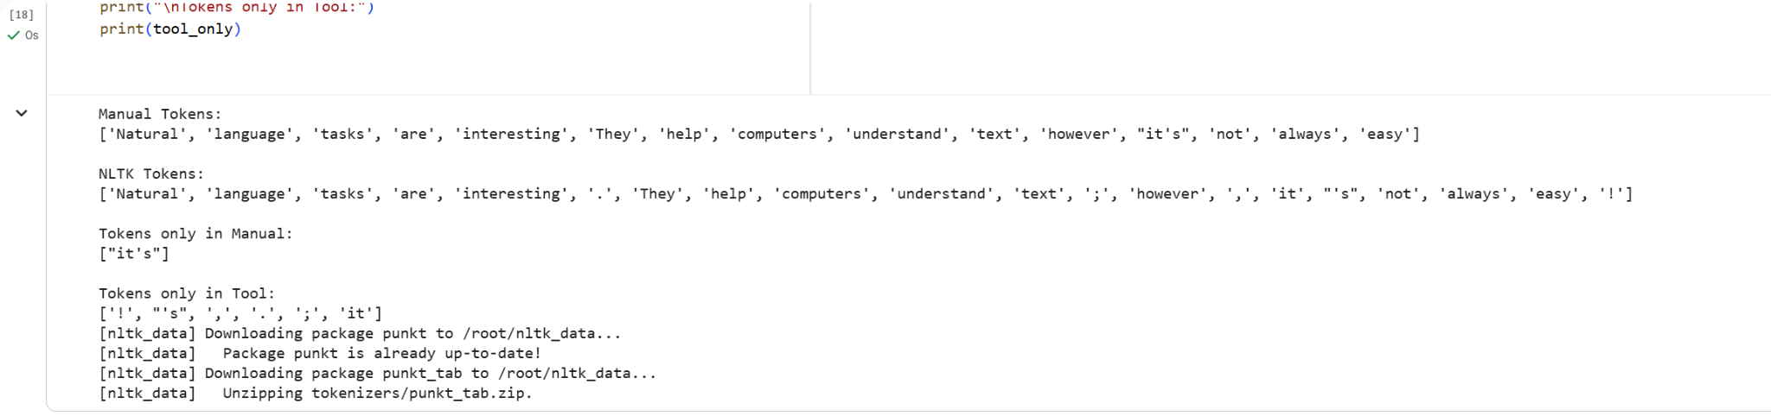
- Which tokens differ? Why?
The tokens differ mainly because the tool splits contractions and keeps punctuation, while the manual method expands contractions and removes punctuation. For example, the tool produces “ca” and “n't” instead of “can” and “not”, and “it” and “‘s” instead of “it” and “is”. It also keeps punctuation like “.”, “!”, and “,” as separate tokens, whereas the manual version removes them. Additionally, the tool treats “New” and “York” as two tokens, while the manual version keeps “New York” as one token since it is a named entity. These differences occur because NLTK uses general rules for tokenization, while the manual method focuses on cleaner, meaning-based word units.
3. Multiword Expressions (MWEs)
Identify at least 3 multiword expressions (MWEs) in your language. Example:
- Place names, idioms, or common fixed phrases.
- Explain why they should be treated as single tokens.
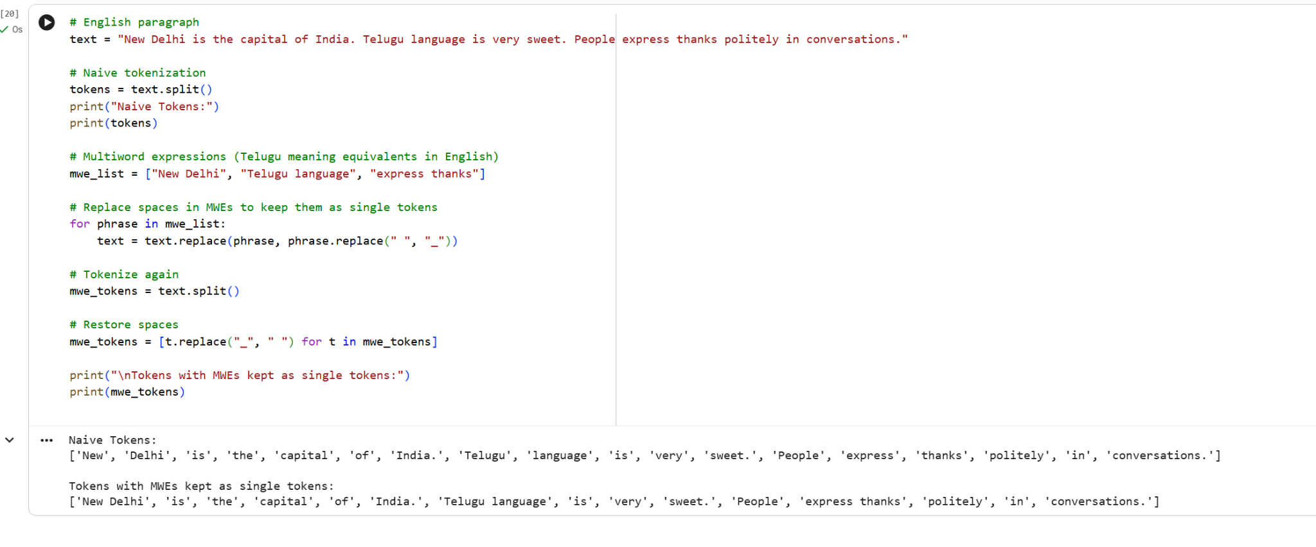
4. Reflection (5–6 sentences)
a) What was the hardest part of tokenization in your language?
The hardest part of tokenization in Telugu is handling words that contain multiple suffixes and grammatical endings attached to a single root word. Telugu is morphologically rich, so one word can express tense, number, and case together, making it difficult to decide where to split. Another challenge is identifying whether a word should stay whole or be broken into smaller meaningful parts.
b) How does it compare with tokenization in English?
Compared to English, tokenization in Telugu is more complex because English usually has clearer spaces between words and fewer suffixes attached to the root. English words are often easier to separate using simple space-based rules, while Telugu requires more understanding of word structure and grammar. English tokenization is therefore generally more straightforward and predictable.
c) Do punctuation, morphology, and MWEs make tokenization more difficult?
Yes, punctuation, morphology, and multiword expressions all make tokenization more difficult. Punctuation attached directly to words can lead to incorrect splits if not handled carefully. Morphology increases complexity because a single Telugu word may contain several meaningful parts combined together. MWEs such as place names and fixed phrases must be kept as single tokens to preserve meaning, which adds another layer of difficulty to the process.

